THE OPEN UNIVERSITY OF SRI LANKA

CERTIFICATE IN LABORATORY TECHNOLOGY PROGRAMME

FINAL EXAMINATION 2013/2014

**PSC 1123:BASIC MATHEMATICS AND COMPUTER SKILLS**

DURATION: **TWO HOURS**(2 HOURS)

**Date: 18hMarch, 2013**  **Time:- 9.30 a.m. – 11.30 a.m.**

**Answer FOUR Questions ONLY.**

**Two questions from each part should be answered.**

**PART - A**

**Q1.**

(i) Using the identity 

Solve the equation

(a) log3(x)-4logx(3)+3=0

Simplify as far as possible

(b) 

(ii) Using the formula

(a)Prove that 

(b) Prove that 

(c) Find the general solution of the equation 

**Q2.**

(a) Find  of the following functions

(i)  (ii) 

(b) Integrate following functions

(i)  (ii) 

**Q3.**

A policeman records the speed of the traffic on a busy road with a 30mph speed limit. He records the speeds of a sample at 450 cars. Evaluated data given below.

|  |  |
| --- | --- |
| **speed 0f cars** | **No. of cars** |
| 10 - 15 | 30 |
| 15 - 20 | 00 |
| 20 - 25 | 120 |
| 25 - 30 | 120 |
| 30 - 35 | 90 |
| 35 - 40 | 30 |
| 40 - 45 | 60 |

(i) Draw histogram of the above distribution

(ii) Calculate the number of cars that were exceeding the speed limit at least 5mph in the sample.

(iii)Estimate to one decimal place the value of the mean, median and mode speed of the cars in the sample.

(iv) Find the value of standard deviation the speed of the cars in the sample.

**PART – B**

**Q4**

Use the following data set on the EXCEL worksheet to answer the questions given below.

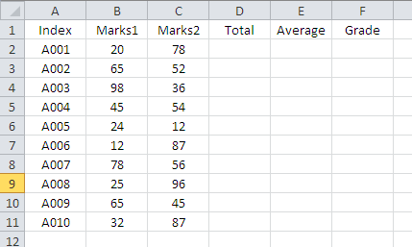

Write the EXCEL functions or formulas to do the following.

i. Get the total marks under column ‘D’ (Total).

ii. Get the average marks under column ‘E’ (Average).

iii. Print the ‘Grade’ of each Index number under column ‘F’ (Grade), according to the following criteria.

|  |  |
| --- | --- |
| Average | Grade |
| <40 | F |
| <55 | S |
| <65 | C |
| <75 | B |
| >=75 | A |

**Q5**

a) Create the following directory structure using **MS DOS** commands

D:\>

Computer

Physics

Zoology

Chemistry

Hardware

Software

b) Suppose there are three files named **data.txt**, **data.doc** and **data.exe** stored in Chemistry sub directory. By considering the root directory (D:\>) as working directory,

i) Copy **data.txt** file into **Computer** sub directory.

ii) Copy **data.doc** file into **Hardware** sub directory.

iii) Copy all files in **Chemistry** subdirectory into **Zoology** sub directory using wild cards.

iv) Delete**data.txt** file in **Computer** sub directory.

v) Remove the sub directory **Physics**

**Q6**

a) Mention the three types of software and describe them briefly.

b) Write examples for each category of applications software listed below.

i) Word processor

ii) Spreadsheet

ii) Presentation program

c) What stands for URL? Why is it used?

d) What is search engine?

e) Write three search engines which are popular today.

****All Rights Reserved****