THE OPEN UNIVERSITY OF SRI LANKA

CERTIFICATE IN LABORATORY TECHNOLOGY PROGRAMME

FINAL EXAMINATION 2014/2015

**PSC 1123:BASIC MATHEMATICS AND COMPUTER SKILLS**

DURATION: **TWO HOURS**(2 HOURS)

**Date: 05thDecember, 2014**  **Time:- 2.00 p.m. – 4.00 p.m.**

**Answer FOUR Questions ONLY.**

**Two questions from each part should be answered.**

**PART - A**

**Q1**

**(i)**Simplify following expressions.

**(a)  (b) **

**(ii)** Let  and  are acute angle. Find the value of

**(a)  (b) **

**(iii)** Shama records the time spent out at school during the lunch hour to the nearest minute , of the female students in her year. The results are as follows.

|  |  |
| --- | --- |
|  | Number of students |
| 35 | 05 |
| 36 | 10 |
| 37 | 30 |
| 38 | 22 |
| 39 | 05 |

Draw a pie chart for the above distribution.

**Q2**

**(i)**Differentiate the following functions with respect to 

**(a) **

**(b) **

**(ii)** Integrate following functions.

**(a) **

**(b) **

**(iii)** A random sample of 200 students was asked how long it took them to complete their homework in the previous night. The time was recorded and summarized in the table below.

|  |  |  |  |  |  |
| --- | --- | --- | --- | --- | --- |
| Time(minutes) | 25-30 | 30-35 | 35-40 | 40-45 | 45-50 |
| Frequency | 55 | 39 | 68 | 32 | 6 |

**(a)**Draw a histogram to represent the data.

**(b)** Draw a frequency polygon to represent the data.

**Q3**

The times it took a random sample of runners to complete a race are summarized in the table.

|  |  |
| --- | --- |
| The time taken  (t minutes) | Frequency |
| 20-30 | 05 |
| 30-40 | 10 |
| 40-50 | 36 |
| 50-60 | 20 |
| 60-70 | 09 |

(i) Estimate the mean and median for these data.

(ii) Estimate the standard deviation and coefficient of skewness.

**PART – B**

**Q4**

Use the following data set on the EXCEL worksheet to answer the questions given below.

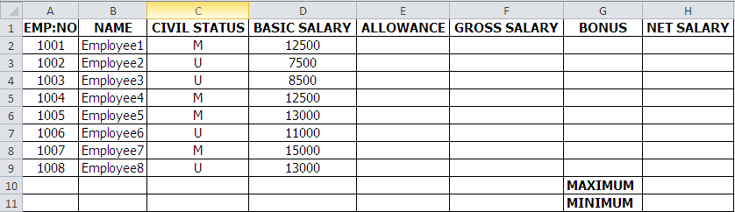

Write the EXCEL functions or formulaeto do the following.

**(i)** Get the **ALLOWANCE**  of the 1st employee into cell **E2**.

(Hint: if Married(M), ALLOWANCE=3000,

if Unmarried(U), ALLOWANCE=1500)

**(ii)**Get the **GROSS SALARY** of the 1st employee into cell **F2**.

(Hint: GROSS SALARY=BASIC SALARY+ALLOWANCE)

**(iii)** Get the **BONUS** of the 1stemployee into cell **G2.**

(Hint: BONUS= BASIC SALARY*1.5)

**(iv)** Get the **NET SALARY**of the 1st employeeinto cell **H2.**

(Hint: NET SALARY= GROSS SALARY+BONUS)

**(v)** Get the **MAXIMUM** and**MINIMUM** values of **NET SALARY**into cells **H10** and **H11**

**Q5**

**(i)**Create the following directory structureusing **MS DOS** commands. In every step show the prompt clearly.

D:\>

Movies

Music

Sports

Education

Football

Cricket

**(ii)**Suppose there are nine(09) files named **data1.txt,data2.txt, data3.txt, data1.doc**, **data2.doc, data3.doc, data1.jpg**, **data2.jpg, data3.jpg**stored in Root directory. By considering the root directory (D:\>) as working directory,

a) Display all “**txt”** files.

b) Display all “**doc”**files.

c) Delete all “**jpg**” files.

d) Delete all remaining files.

e) Remove the sub directories **Music** and **Movies**

**Q6**

**(i)**Compare and contrast the following terms.

a) “System Software” and “Application Software”

b) “MS-DOS” and “Windows”

**(ii)** Explain briefly the following terms.

a) URL b) protocol c) TCP/IP

**(iii)**a) Explain briefly the roll of the Web Browser.

b) Write three Web Browsers popular today.

**(iv)** Write three search engines popular today.

****All Rights Reserved****